Policies_Verifying Agency Billed Policy_Instance43_29-May-2018_02-55-33_AM_ValidationofAgencyBilledPolicy.png

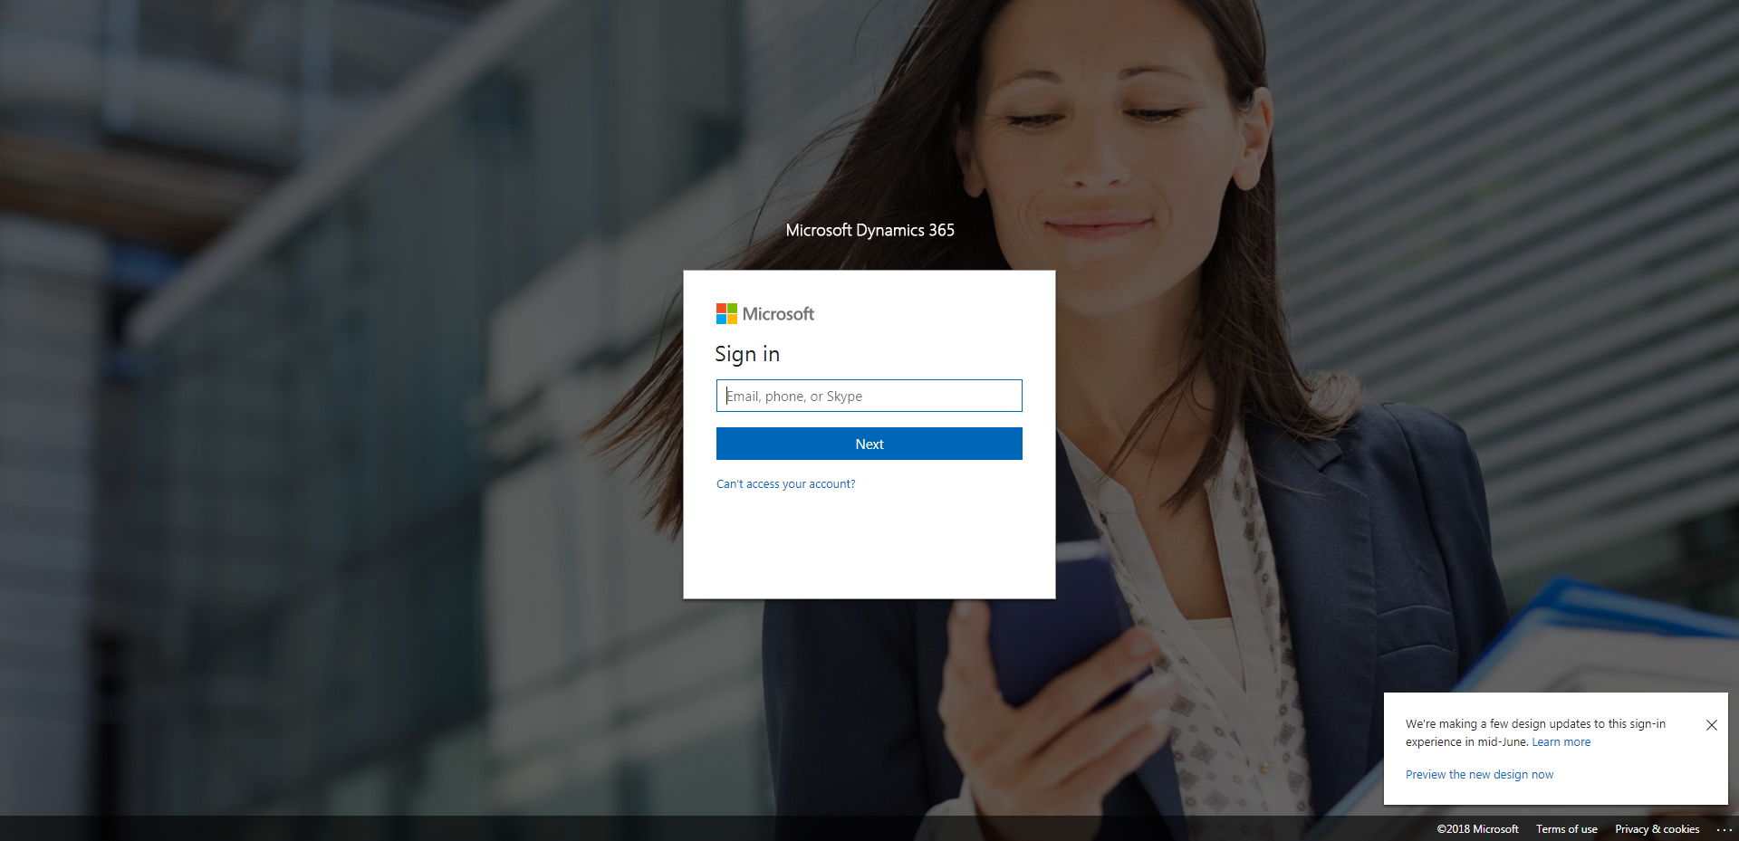

Policies_Verifying Agency Billed Policy_Instance43_29-May-2018_02-55-31_AM_SingleSignOn.png

